Kevin Abrahams

CMSC335 Project 3

3/2/21

**User’s Guide (How Start the Program)**

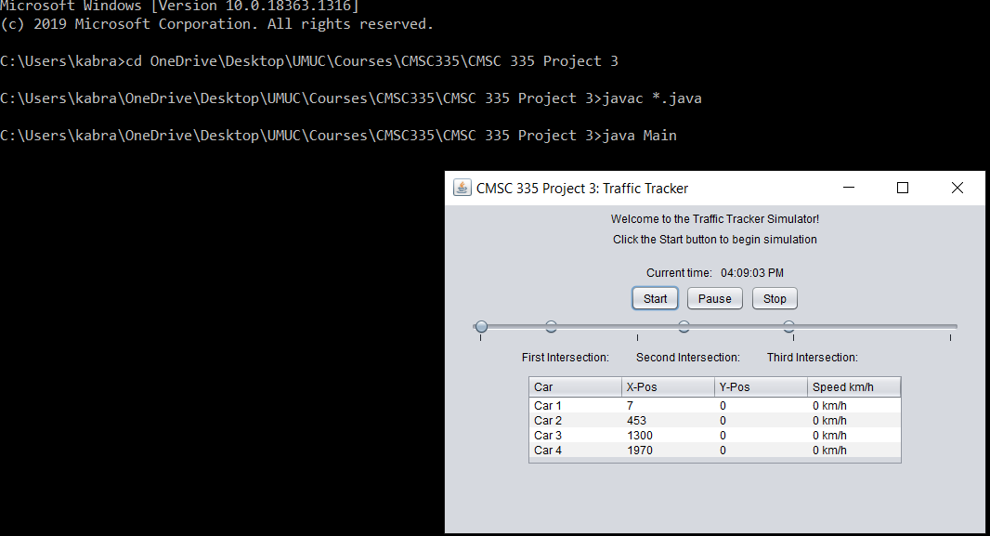 To run the application, the user should first download the project folder called CMSC 335 Project 3 and then navigate to the current directory of the project folder via command line using the cd, change directory, command. After navigating to the current directory of the project folder, the user should then compile all of the java files contained in the folder using the javac *.java command. Then, the user should run the program via the command java Main, which shall cause the GUI application to start and appear onscreen. The screenshot below illustrates all these steps.

**Test Cases**

1. 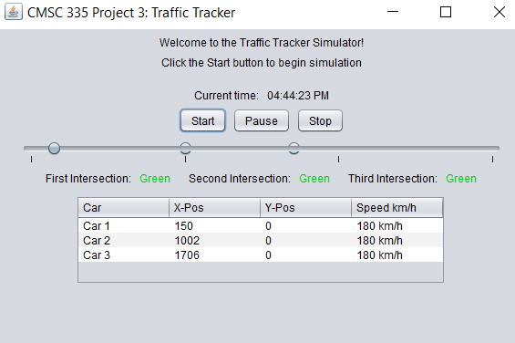The first test case involves the start button. Upon pressing the start button, the program successfully launches, and cars begin moving.

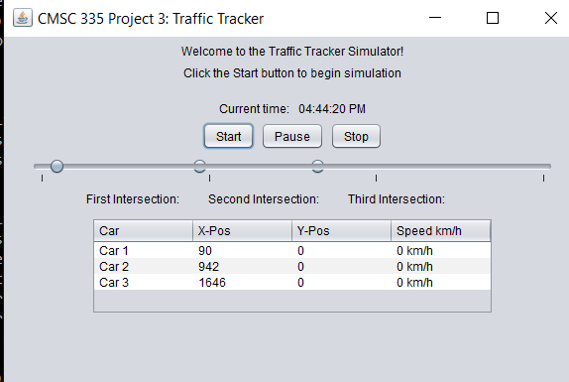

1. The second test case involves the pause button. Upon pressing the pause button, the cars stop moving temporarily, and a new button called continue replaces the pause button in the middle, indicating for the user to recontinue the program. 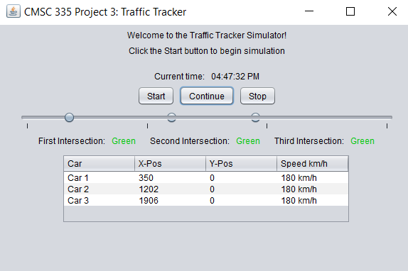
2. The third test case involves pressing the continue button which appears after the user pauses the program. After pressing the continue button, the program successfully rebegins, and the cars resume their movement. The continue button in the middle is then replaced with the pause button after the user presses it. 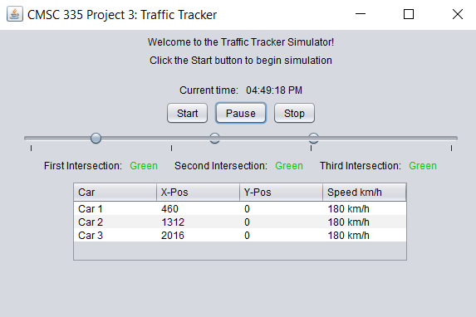
3. The fourth test case involves the yellow intersections. When the intersections turn red, the cars correctly to move at their regular speed undisturbed and don’t slow down. 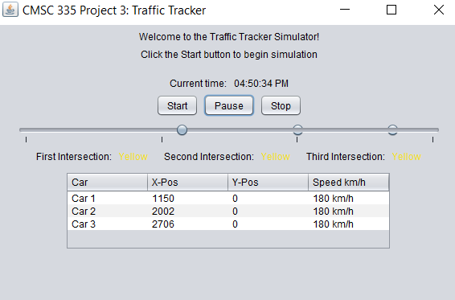
4. 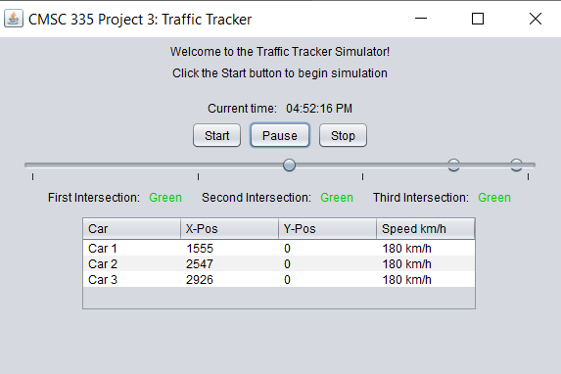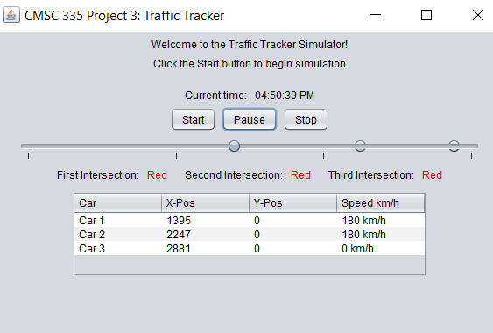The fifth test case involves the red intersections. When the intersections turn red, the cars correctly stop immediately at a dime once they have gotten near the respective intersections in front of them. Then, once the intersections turn green once again, the cars resume their movement.
5. 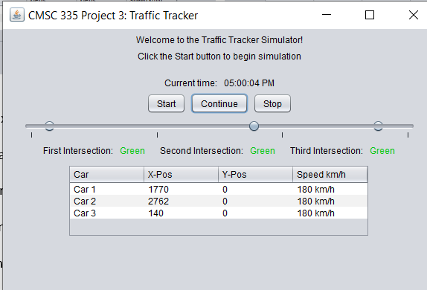The sixth test case involves the stop button. When the stop button is pressed, the simulation is successfully stopped and terminated, meaning that the simulation no longer responds to the user pressing the pause or continue button, as the following screenshots indicate and illustrate.

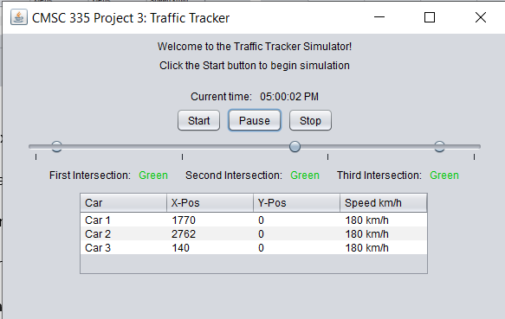

1. 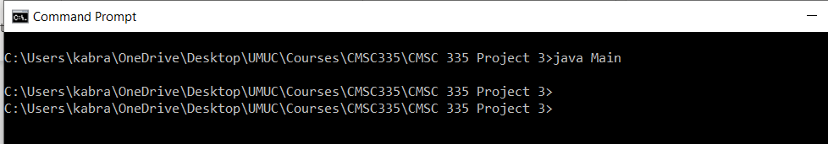The seventh test case involves exiting the program. Now that the simulation has been stopped, the user can then terminate the program by closing the Traffic Tracker window.

**Lessons Learned**

This program was invaluable for teaching me more about creating GUI applications in Java and more regarding threads and concurrency. I learned more about how to use threads and Java Swing AWT components. It was also interesting developing complex, intricate classes with a predefined relationship. I learned a lot more about built-in Java classes and how to integrate and utilize them in my own program to form a comprehensively effective programmed solution. This programming assignment effectively built off from my previous programming skills and expanded them.

**UML Diagram**

